**Solution screenshots for Postman Project**

**Creating Well-Structured Output for API Clients Using Postman to Get Weather Report**

**Steps followed:**

**1. Creating a collection**

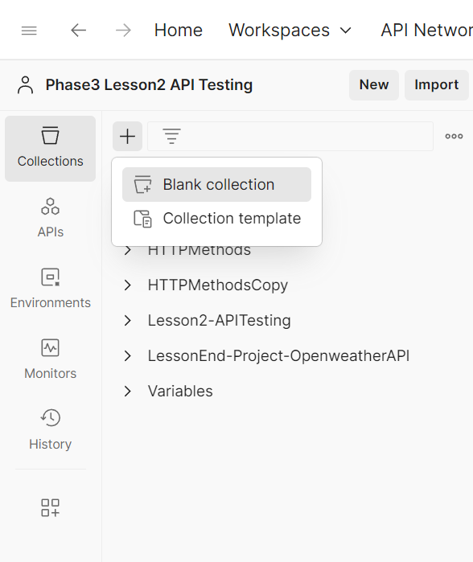

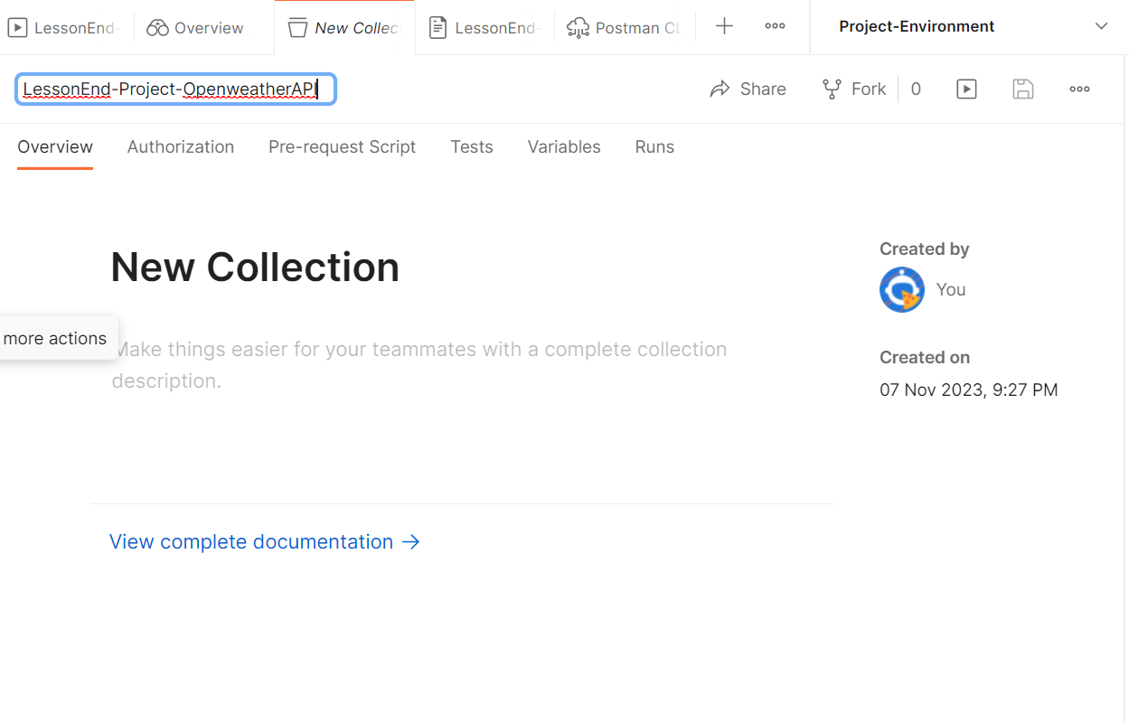

**2. Creating a request by using api key from the given website**

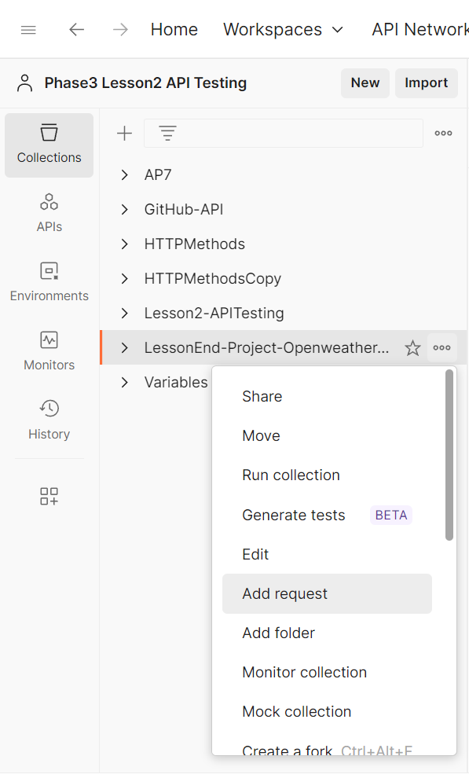

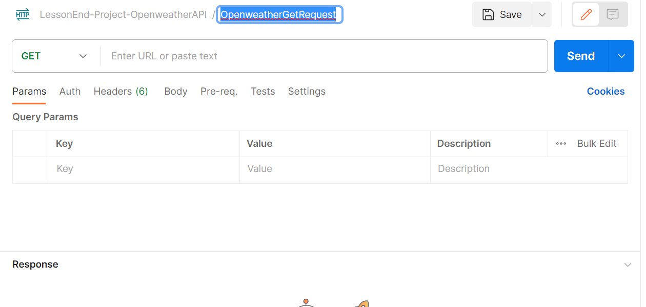

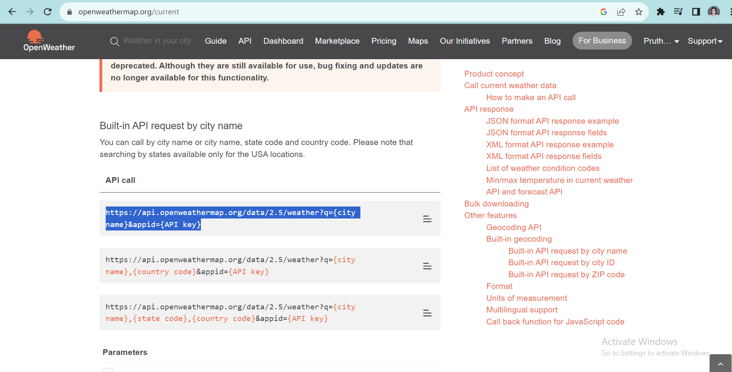

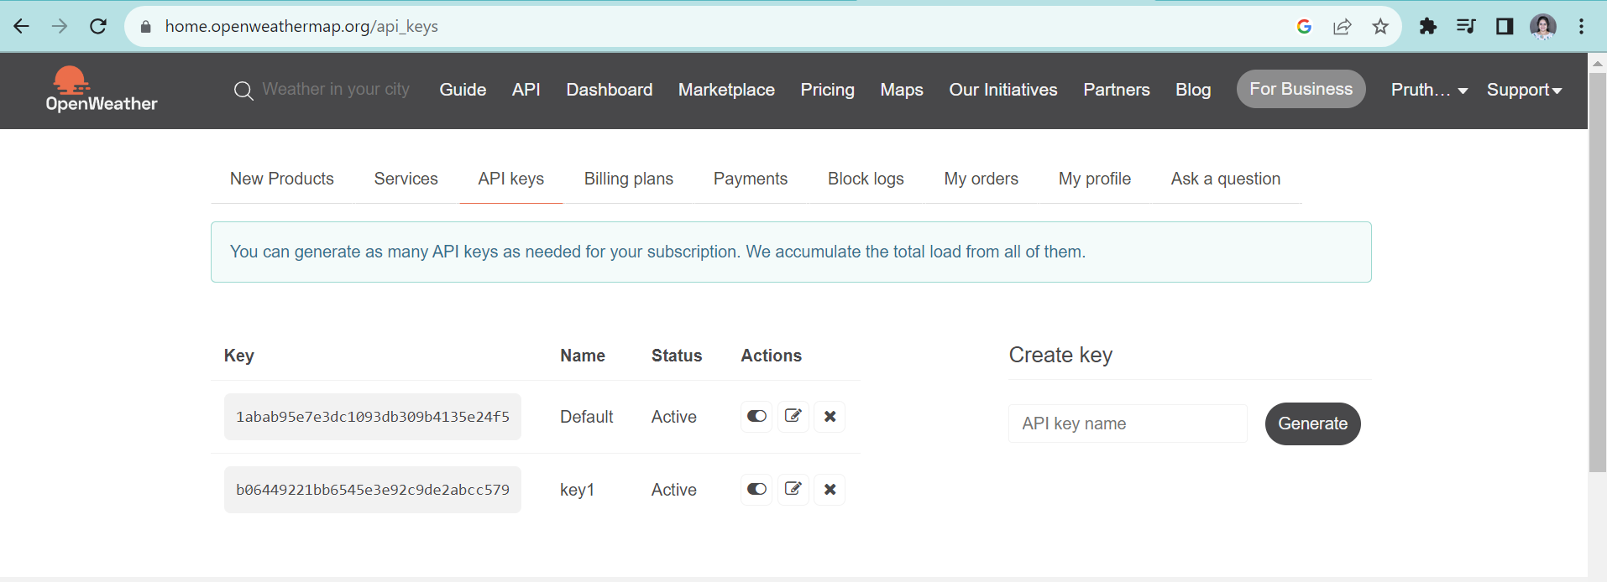

**3. Using environment variables for the request URL**

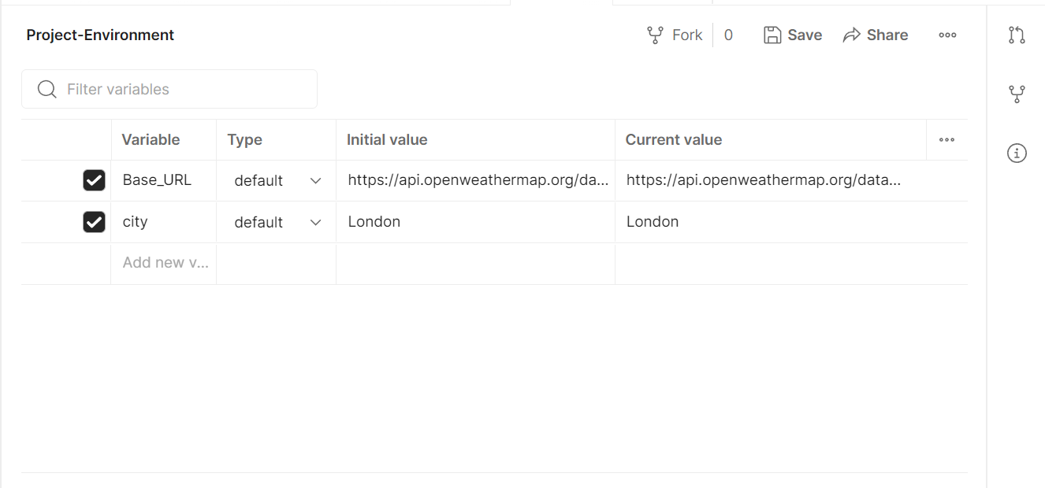

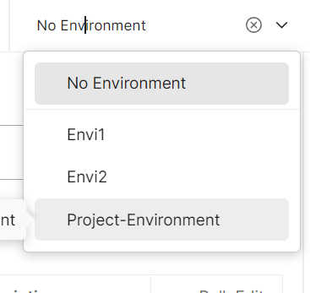

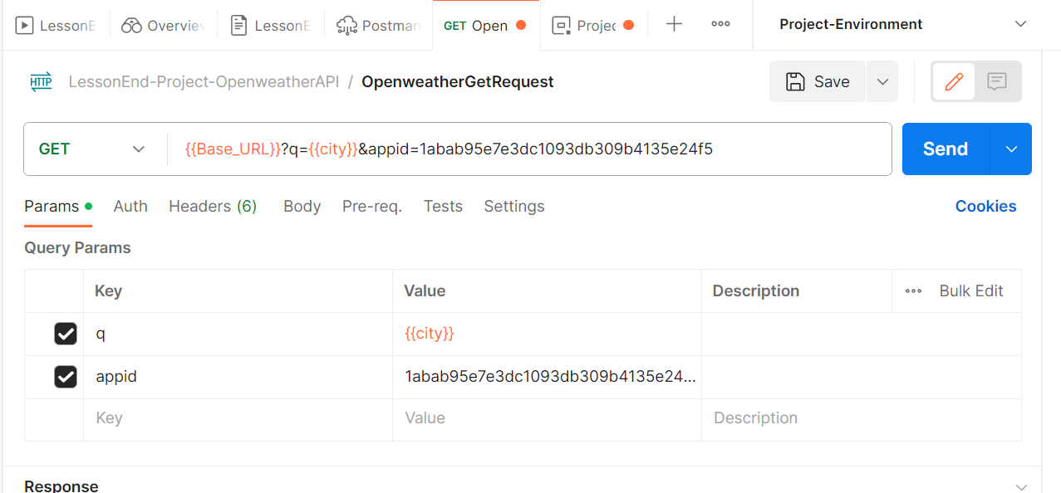

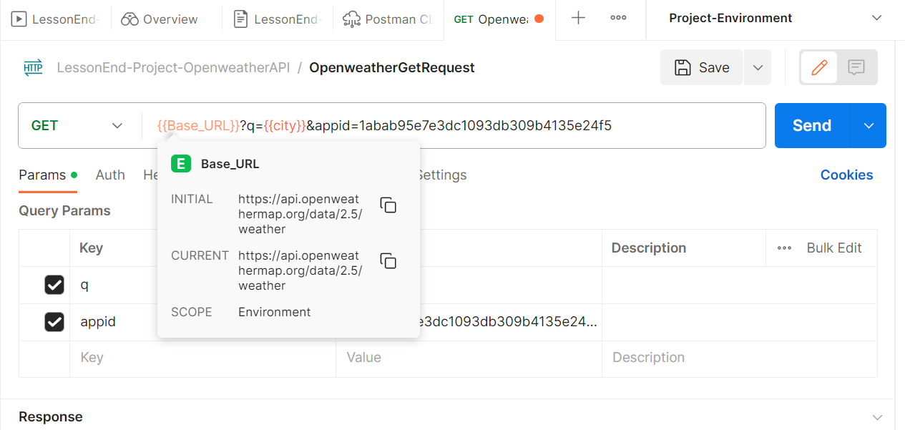

**4. Writing a test script for response assertions**

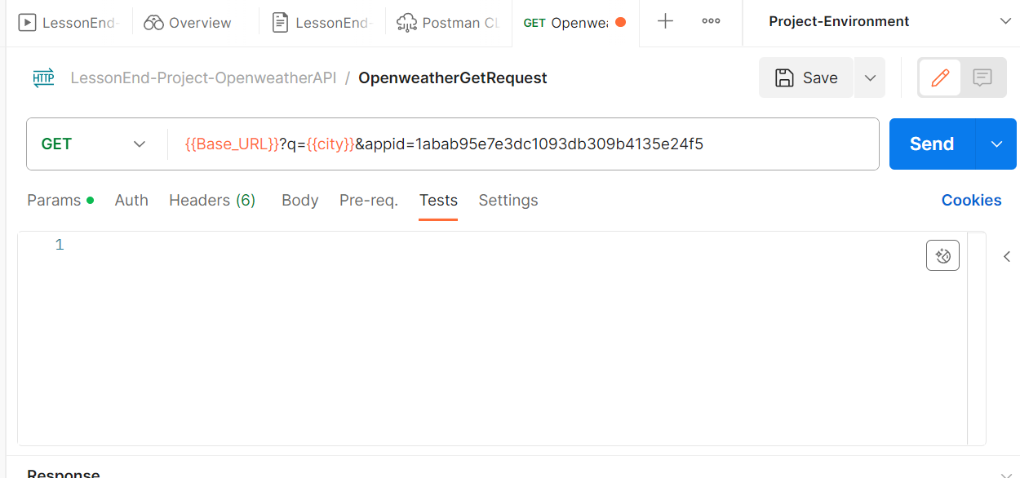

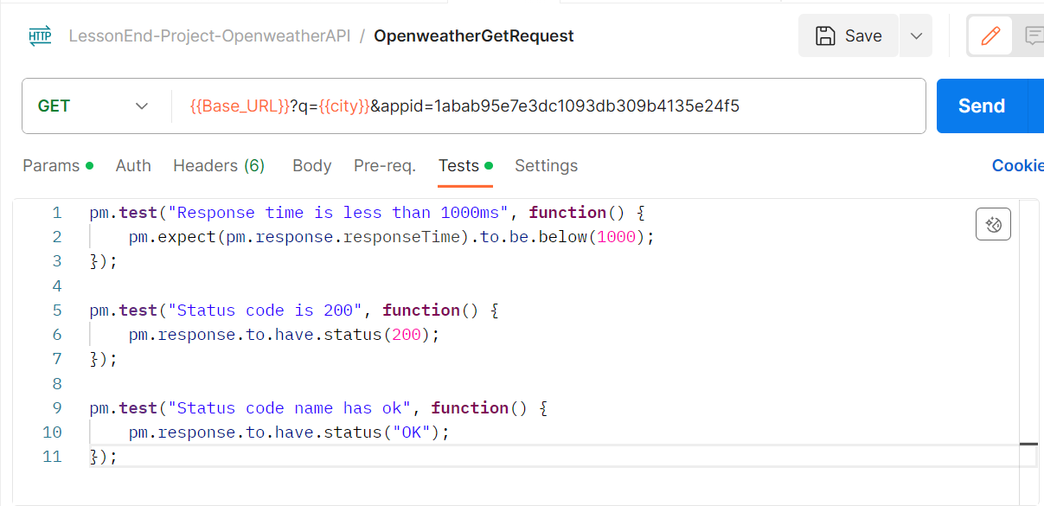

**5. Getting weather report for London and checking Test results**

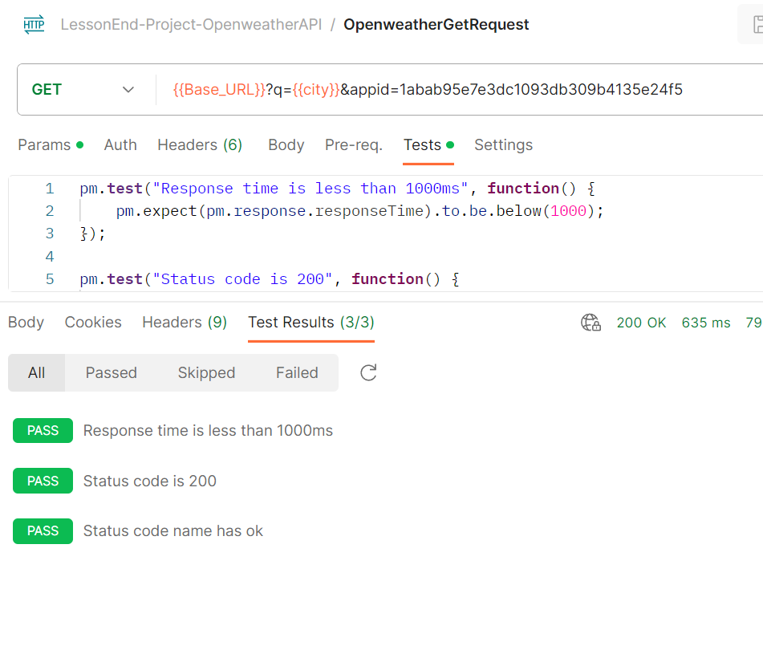

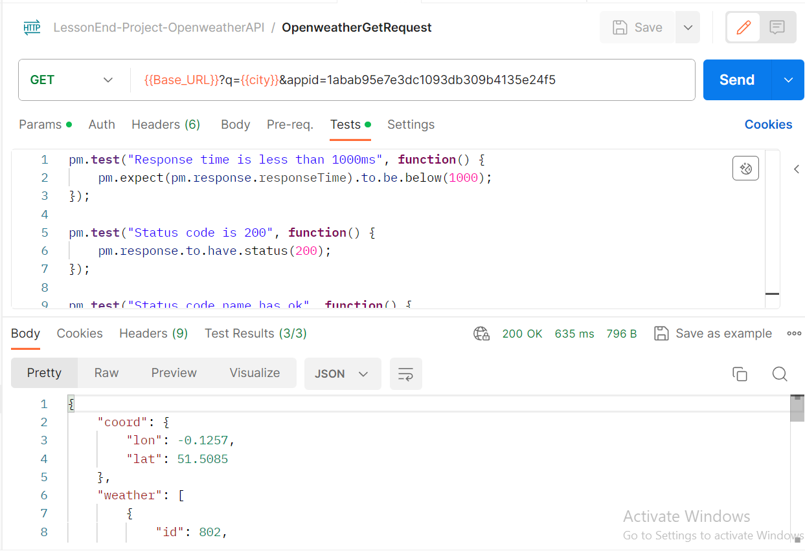

**Response body:**

{

    "coord": {

        "lon": -0.1257,

        "lat": 51.5085

    },

    "weather": [

        {

            "id": 802,

            "main": "Clouds",

            "description": "scattered clouds",

            "icon": "03d"

        }

    ],

    "base": "stations",

    "main": {

        "temp": 284.25,

        "feels_like": 283.45,

        "temp_min": 282.9,

        "temp_max": 285.37,

        "pressure": 1007,

        "humidity": 78

    },

    "visibility": 10000,

    "wind": {

        "speed": 5.66,

        "deg": 250

    },

    "clouds": {

        "all": 40

    },

    "dt": 1699374048,

    "sys": {

        "type": 2,

        "id": 2075535,

        "country": "GB",

        "sunrise": 1699340631,

        "sunset": 1699374269

    },

    "timezone": 0,

    "id": 2643743,

    "name": "London",

    "cod": 200

}

**6. Run using collection runner**

